Coursework Assignment

Louis Pepin-Dineen  
6574141  
lp00676

10/01/2020

L.Dineen

1. Developing and Testing Environment

I used draw.io to draw the EER diagram and schema. I used XAMPP which was used in the lab sessions to create and test my SQL database. I used atom IDE to write my php code and tested it on Microsoft Edge 44.18362.449.0 on Windows 10 Home.

2. EER Data Model and Diagram

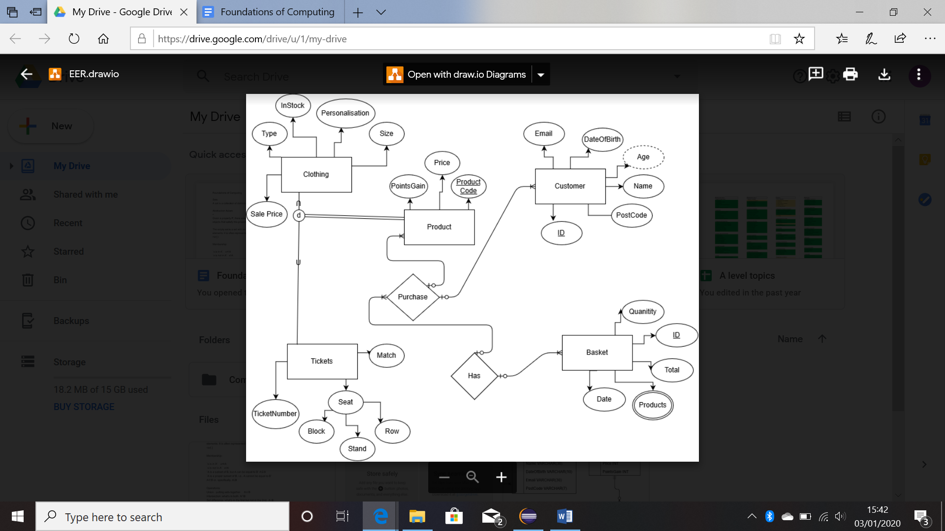

A customer can purchase a product which is a supertype of both clothing and tickets because they both share the common attributes: product code, price and points gained. The subtypes are disjointed as a product cannot be both a ticket and clothing item but only one or the other. A purchase also has a basket which contains all products to be bought along with a total price and date.

3. Conceptual/Logical Relational Database Schema

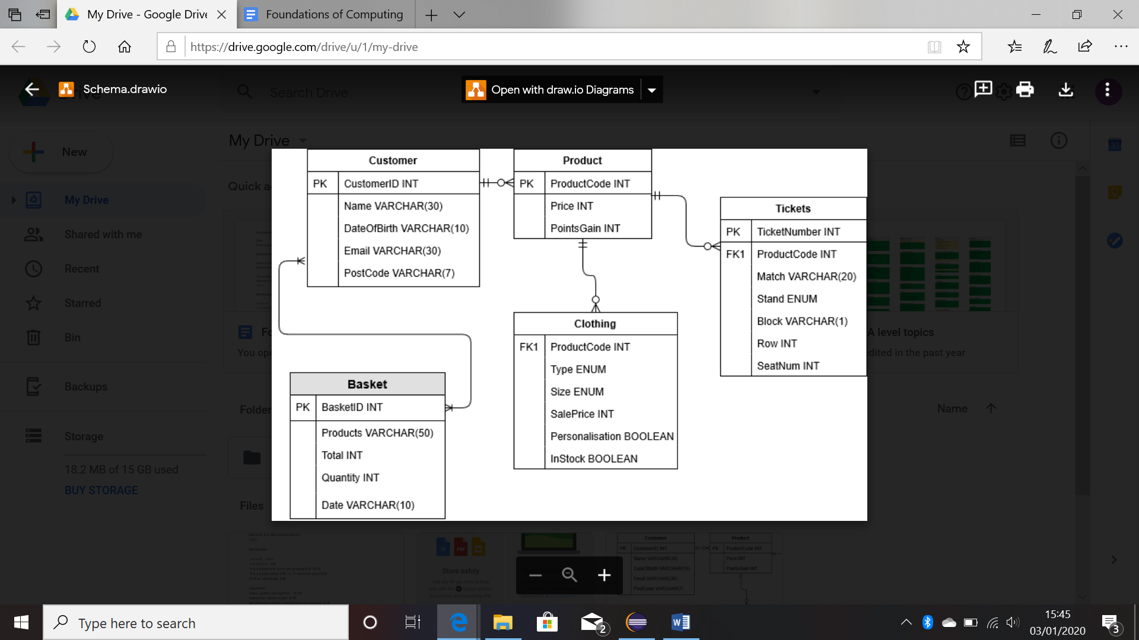

4. MySQL Code

In my SQL code I created 4 tables and populated them with varied dummy data. In my php code I selected all clothing items that were in stock, and displayed the type, size and sale price. This shows customers what clothes are available to buy along with their price. I then updated the jumper to be out of stock. I used if statements to check the connection and each SQL retrieval, that display error messages if there is an error.

5. Website Working with MySQL Database

I only used one file for my website called Coursework.php.

6. Advanced Tasks

I did not attempt any advanced tasks.